**Scenario:** **Moving data from AWS S3 bucket to azure SQL (if file size > 100kb and rows in file > 999)**

**Source**: Amazon S3 Bucket

**Destination**: Azure SQL

**Platform** **Used**: Azure Data Factory

1. First, we need to create an S3 bucket in AWS console
2. We need to add a container
3. Add files in to S3 container
4. Create a user and user group
5. Under user we need to create access key and access secret (it can be used to connect s3 bucket)
6. Give get access, list object access of s3 bucket to created user
7. Create linked service to connect s3 bucket in azure data factory
8. Create another linked service to azure SQL
9. Create data set relevant to S3 and azure SQL
10. Create pipeline with set of activities and apply logic regarding to size > 100kb and rows in a file > 999
11. End point to azure SQL
12. Check in Azure SQL for final output

**AWS🡪**

**Creating amazon S3 Bucket**

* **Sign In to AWS:** 
  + Go to the AWS website and sign in with your credentials.
* **Navigate to S3:**
  + **F**rom the AWS Management Console, use the search bar at the top to type “S3” and select it from the results

* Bucket will be displayed like this

* Now creating folder inside s3 bucket and adding files .

* Click on create folder

* Add files inside the folder

* Create a user and user group under IAM.
* Click on IAM

* Click on users
* Create user🡪 s3access

* Create user group or select if already created

* Selecting created user group

* Click on review and create

* User will be displayed like this

* Under the permissions 🡪 click on add permissions 🡪 add inline policy 🡪 select JSON

* Copy and paste the code (get object and listbucket used to select and access files in s3 bucket from azure)

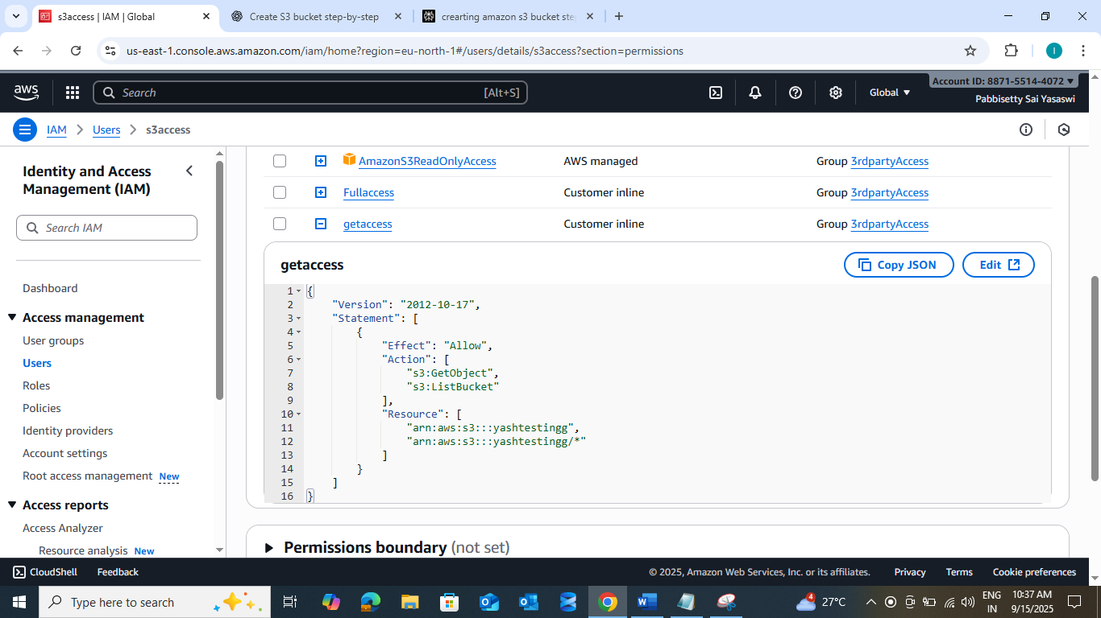

{

"Version": "2012-10-17",

"Statement": [

{

"Effect": "Allow",

"Action": [

"s3:GetObject",

"s3:ListBucket"

],

"Resource": [

"arn:aws:s3:::yashtestingg",

"arn:aws:s3:::yashtestingg/*"

]

}

]

}

* Create access key under IAM 🡪 select S3 access (created user) 🡪 generate and note user name and password

* **Create linked service in azure to connect amazon s3:**
  + Select s3

* + Give access key and access secret test connection

* + Click on test connection

* **Creating linked service to connect AZURE SQL**
  + Click on manage 🡪 select linked services 🡪 create 🡪 azure sql database🡪
  + Test connection

* **Creating data sets for both amazon s3 and azure sql:**
  + **Ds_getfileSize_individual:**

* **Ds_Azuresql:**

**Pipeline overview:**

Inside Foreach

* **Creating pipeline:**
  + **Getmeta data:**

* **For each:**

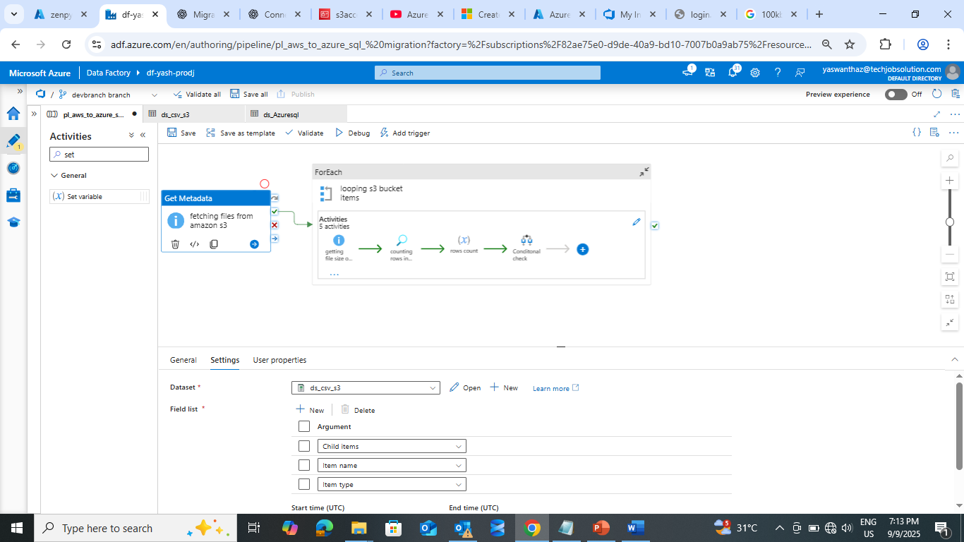

For each syntax:

@activity('fetching files from amazon s3').output.childItems

* Inside for each getting individual file size

* Counting number of rows in each file for that am using lookup and set variable

* Using set variable to count number of rows in each file

Code :

@length(activity('counting rows in each file').output.value)

* Conditional check to check file size > 100KB and rows count > 999 then only it goes to true case other wise goes to false and stores in log table

* If condition

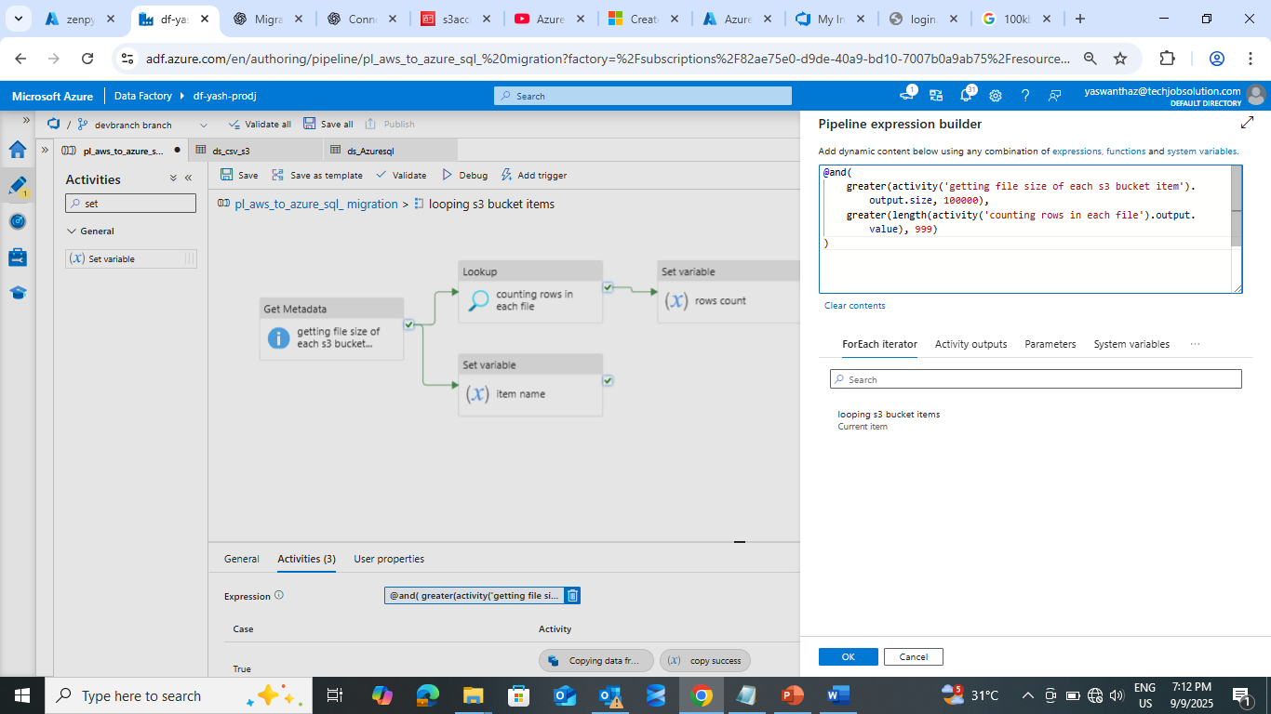

Logic:

@and(

    greater(activity('getting file size of each s3 bucket item').output.size, 100000),

    greater(length(activity('counting rows in each file').output.value), 999)

)

**Pipeline Success**:

* In execution it will check and filtered the files based on file size > 100kb and rows > 999 then it will store in to AzureSql as a table with same file name

Ex: source file name: bikesales.csv

Destination Azure Sql table name: dbo.bikesales

* True condition need to store data in azure sql🡪 created copy activity

* In sink I have mentioned some logic to remove filename extensions of csv files

Example: bikesales.csv (source)🡪 destination bikesales(sql table)

Logic: @split(variables('itemname'), '.')[0]

* Status I am showing with set variable

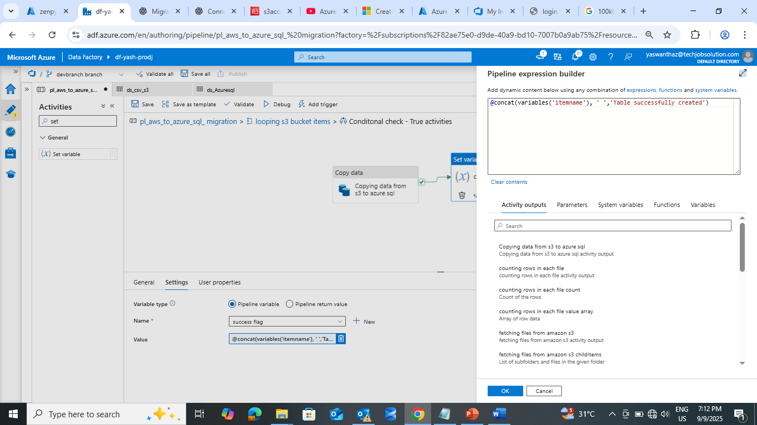

@concat(variables('itemname'), ' ','Table successfully created')

* Azure sql checking

* **Pipeline Failure:** In failure scenario it will store the filename and issue of failure in dbo.fileloadlog

* **Creating stored procedure to store the logs**
  + Creating a table in azure

**Table syntax:**

**CREATE TABLE dbo.FileLoadLog**

**(**

**LogID INT NOT NULL PRIMARY KEY,**

**TableName NVARCHAR(200) NULL,**

**NoOfRecords INT NULL,**

**FileSizeKB DECIMAL(18,2) NULL,**

**FailureReason NVARCHAR(500) NULL,**

**LogDate DATE NULL**

**);**

* + Creating stored procedure in azure sql

**Procedure syntax**:

CREATE   PROCEDURE dbo.LogFileFailure

    @TableName NVARCHAR(200),

    @NoOfRecords INT,

    @FileSizeKB DECIMAL(18,2),

    @FailureReason NVARCHAR(500),

    @LogDate DATE

AS

BEGIN

    SET NOCOUNT ON;

    INSERT INTO dbo.FileLoadLog (TableName, NoOfRecords, FileSizeKB, FailureReason, LogDate)

    VALUES (@TableName, @NoOfRecords, @FileSizeKB, @FailureReason, @LogDate);

END;

* Create stored procedure activity in adf and select created adf and mention the parameters values

* Parameters syntax:
  + FailureReason:

@concat(

  variables('itemname'),

  ' ',

  string(activity('getting file size of each s3 bucket item').output.size),

  ' bytes (less than 100000), ',

  string(length(activity('counting rows in each file').output.value)),

  ' rows (less than 999)'

)

* + FileSizeKB:

@activity('getting file size of each s3 bucket item').output.size

* + LogDate:

@formatDateTime(utcNow(), 'yyyy-MM-dd')

* + NoOfRecords:

@variables('rowscount')

* + TableName:

@variables('itemname')

* **Error logs inside log table:**

